Newsletter – November 2017

Dear Parents and Carers,

Welcome back to school! Term 1 really flew by and it feels like everyone is settling into the new school session. Our Primary 1 children have made a fantastic start to school and are proving to be confident and making contributions to school life already! We’re all getting to know each other well and now looking forward to Term 2 which is always busy and exciting as we approach Christmas.

**Sheltie Stakes**

It already feels like a distant memory, but what a fantastic day! Well done to everyone involved in organising such a professional and enjoyable event. Our thanks for the generosity of the Sheltie Stakes Committee in giving the FSA 6500 pounds! It’s a huge amount of money for which we are really grateful. We are making use of the money in consultation with FSA. I am delighted to inform you that the FSA funded IPADS have arrive, have been loaded with APPS, have super protective covers and are charged and ready to go! This means that a whole class can work on the IPADS at the same time, which will be particularly useful for the P5/6/7 class as they begin to work on their profiles.

We have also begun to purchase whole class readers. So far we have Charlie and the Chocolate Factory, being enjoyed by the P3/4 class, and Danny the Champion of the World, P5/6/7 reader. P1 have a fabulous Gruffalo resource which will inspire them further with their topic. We also are awaiting delivery of Scottish Heinemann Maths resources for the P3/4 class. This will greatly enhance numeracy and will offer us an alternative to TJ Maths resources.

**Pupil Council**

Following our successful election we have a fantastic pupil council who will meet most months to discuss views from the children across the school. We have allocated them a budget in order to buy new equipment for the playground. They will also have responsibilities through the school session as these arise.

**The School Community**

Your support at the Book Fair raised £86 pounds for school books, thank you. 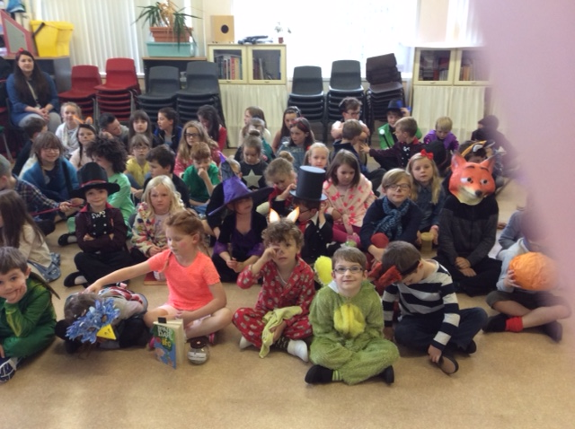Our Roald Dahl Day raised £44.35 for the Dahlicious Children’s Charity and was a huge success, much enjoyed by both children and teachers.

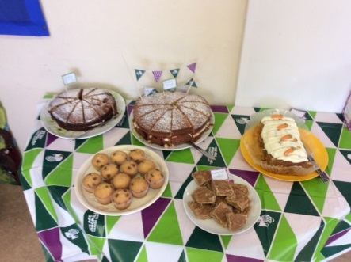Our Macmillan coffee morning was also great success and hugely enjoyed not least by Pupil Council, who served teas and coffees very well. You raised a wonderful £304.26 for the charity. The cakes and treats were just delicious!

Our Harvest Assembly was also very well attended and as usual the children sang beautifully. Rev. Swindells entertained us all with a very amusing story about his bag of shopping and some seeds. Thank you Sean. The school community collected a mighty 108.25 kg of food for the food bank which was really fantastic.

It’s really quite remarkable to think that Hatton of Fintray School can achieve so much that supports the wider community in such a short space of time. Well done everyone!

**More thank yous…**

Thank you very much to Mrs Claire McLeod (Lewis, P1) who has kindly donated a large number of books to the school. The books are in sets of around 15 and come with teacher’s guides and will provide additional whole class readers across the school. These resources would have cost several hundred pounds to buy.

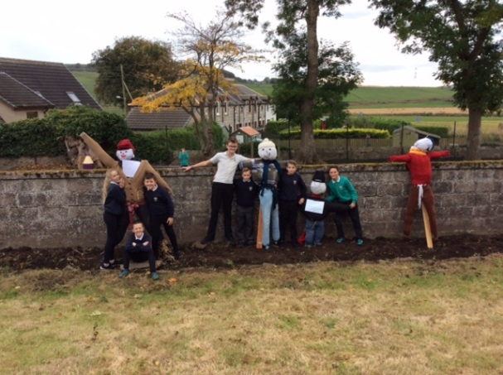

Thank you to Mrs Fyfe and Mrs Cunningham for supporting children during our scarecrow making event. It was great to see the children working in their school houses to produce such great scarecrows!

**Staffing**

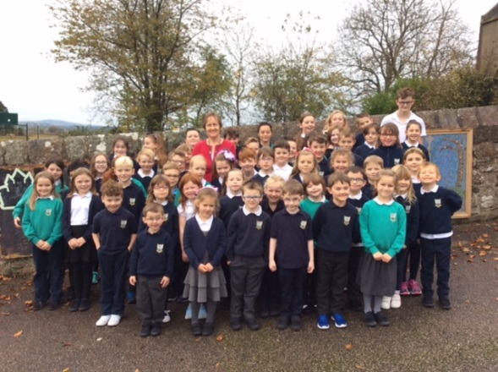As you are aware, Mrs Lucy Burchell’s last day with us was on Tuesday 30th October. We would like to take this opportunity to express our gratitude to Mrs Burchell for her nine years as PSA at our school. She will be missed.

We have PSA cover for five days and then are pleased to Welcome Ms Aithne Rennie who will be working three days a week. Mrs Dempsey will be working two days a week and we are delighted that she will be able to share her great experience with Ms Rennie and help her settle in.

Mrs Massie is reducing her days from five to three days as our administrator. We welcome Mrs Lucy Hay who is joining us as Clerical Assistant. Mrs Hay will be in the office on Wednesday and Fridays and we look forward to welcoming her to school soon.

**Visiting Specialists**

We are very lucky to have Mrs Jan Andrew continuing with us this session. She will continue to teach both drama and art across the school. M. Journe will be teaching French on Thursday and PE will take place on Monday and Wednesday as previously.

**Basketball**

This term we have secured Basketball delivered by Mr Kenneth Gibb from Active Schools. This will take place on Wednesday afternoons and as mentioned previously, children will come home from school in their PE kit enabling us to ensure that they have the maximum amount of time in the village hall or on the pitch developing their skills.

**Reporting**

Following on from the feedback you were invited to give last year, our school reporting process is being updated. We will be in touch with you again as the new format progresses. We will also be producing a reporting calendar which will highlight opportunities for you to find out what’s going on in school. Reporting is a collaborative process and upper stages children will be taking increased responsibility for tracking their own learning, using profiling. Using a range of APPS, children will produce an electronic scrap book style profile, which will include their Learning Intentions and Successes, pictures, films, sounds, examples of their work and will also make strong links to their out of school activities and achievements. Parents will be invited into school to look at this later in the session. It may also be available online, as children will have access to OneDrive.

A written school report, prepared by your child’s teacher will continue to be produced in the spring and the format for this will be shared at an FSA meeting.

**School Website**

We are currently updating our school website and will let you know when this useful resource is fully up and running. Newsletters like this one will be posted on the website, as will newsletters produced each term by your child’s class teacher. Our School Handbook will be linked to the website, as will other information about school and the calendar for the session. We also hope to make more use of the school Facebook page and Twitter. More on this later in the term.

**Coming Up!**

We will be participating in the Children In Need national event on Friday 17th November. More information to follow.

We may be seeking a little help from parents in the coming weeks as we try to tidy up the reading scheme. If you do have a little time to spare, do let us know as there are lots of jobs around school that make a big difference to the daily lives of both the children and staff.

Thank you all for the lovely welcome you have extended to all the new (and returning) staff.

Kind regards,