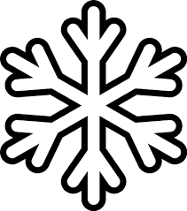**Snow Day Activities 2015 – 2016 P1/2**

Winter in French

1. Find a French song on youtube and learn to sing it. Can you understand what it means?
2. Get ready to perform your song when you get back to school. Perhaps you could work with a friend.

Snow Sculpture

1. Build a snow sculpture. It can be anything you like.
2. Take a picture of it.
3. Then draw/write a set of instructions for building your sculpture.
4. Pass your instructions to a friend or family member. Ask them to make the sculpture, following your instructions.
5. Are they similar? How could you make your instructions better?

Snow day diary

Keep a diary of your snow days. Remember to write and/or about everything that happened during the day. What did you learn? What would you like to do tomorrow?

Clear the snow away

Design your own snow plough that could clear the whole of Hatton of Fintray. Draw a picture of your snow plough and describe why it is so good.

Snow Day Reading

Choose a book you have read recently. Create a new front cover for it.

Snow Day Art

Create a piece of art work that shoes what you can see out your window. You can present your work in any way you choose.

Winter Writing

Choose a winter word and create an acrostic poem for the word.

Examples: winter, snow, snow day, Christmas (or any other one you choose)

Snow Science

1. Find 2 cups and fill them with snow.
2. Add some salt to one cup.
3. Time how long it takes the snow in each cup to melt.
4. Which cup of snow melts faster?
5. Why do you think this is?
6. Draw pictures to show what happened.

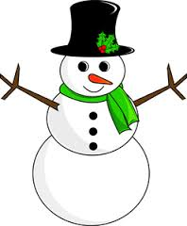

Role Models

1. Why are role models important?
2. Who is your role model and why?
3. What makes you a good role model?

You can present your work in any way you choose.

Sledging

Measure how far you go in your sledge.

Word Factory

How many words can you think of that can be used instead of:

* Said
* Walked
* Happy
* Sad
* got

Number bonds Practice

Practice your number bonds in any way you choose. You could create a poster, game, or even write them in the snow. You could use topmarks.com to help practice.

Winter Spelling

Practice your spelling words by writing them in a snowy way. The choice is yours.

Display your work in an artistic way.

Measure a snowman

Build a snowman and measure it using your hands. How many hands high is it?

Don’t forget your homework!

Complete any homework due that week.