**Hatton of Fintray**

**P1/2 Newsletter Term 2 2017**

Reminders…

Please ensure your child has a gym kit kept in school – Gym is on Mondays & Wednesdays.

Library is on a Tuesday so please remind your child to return their book so they can select a new one.

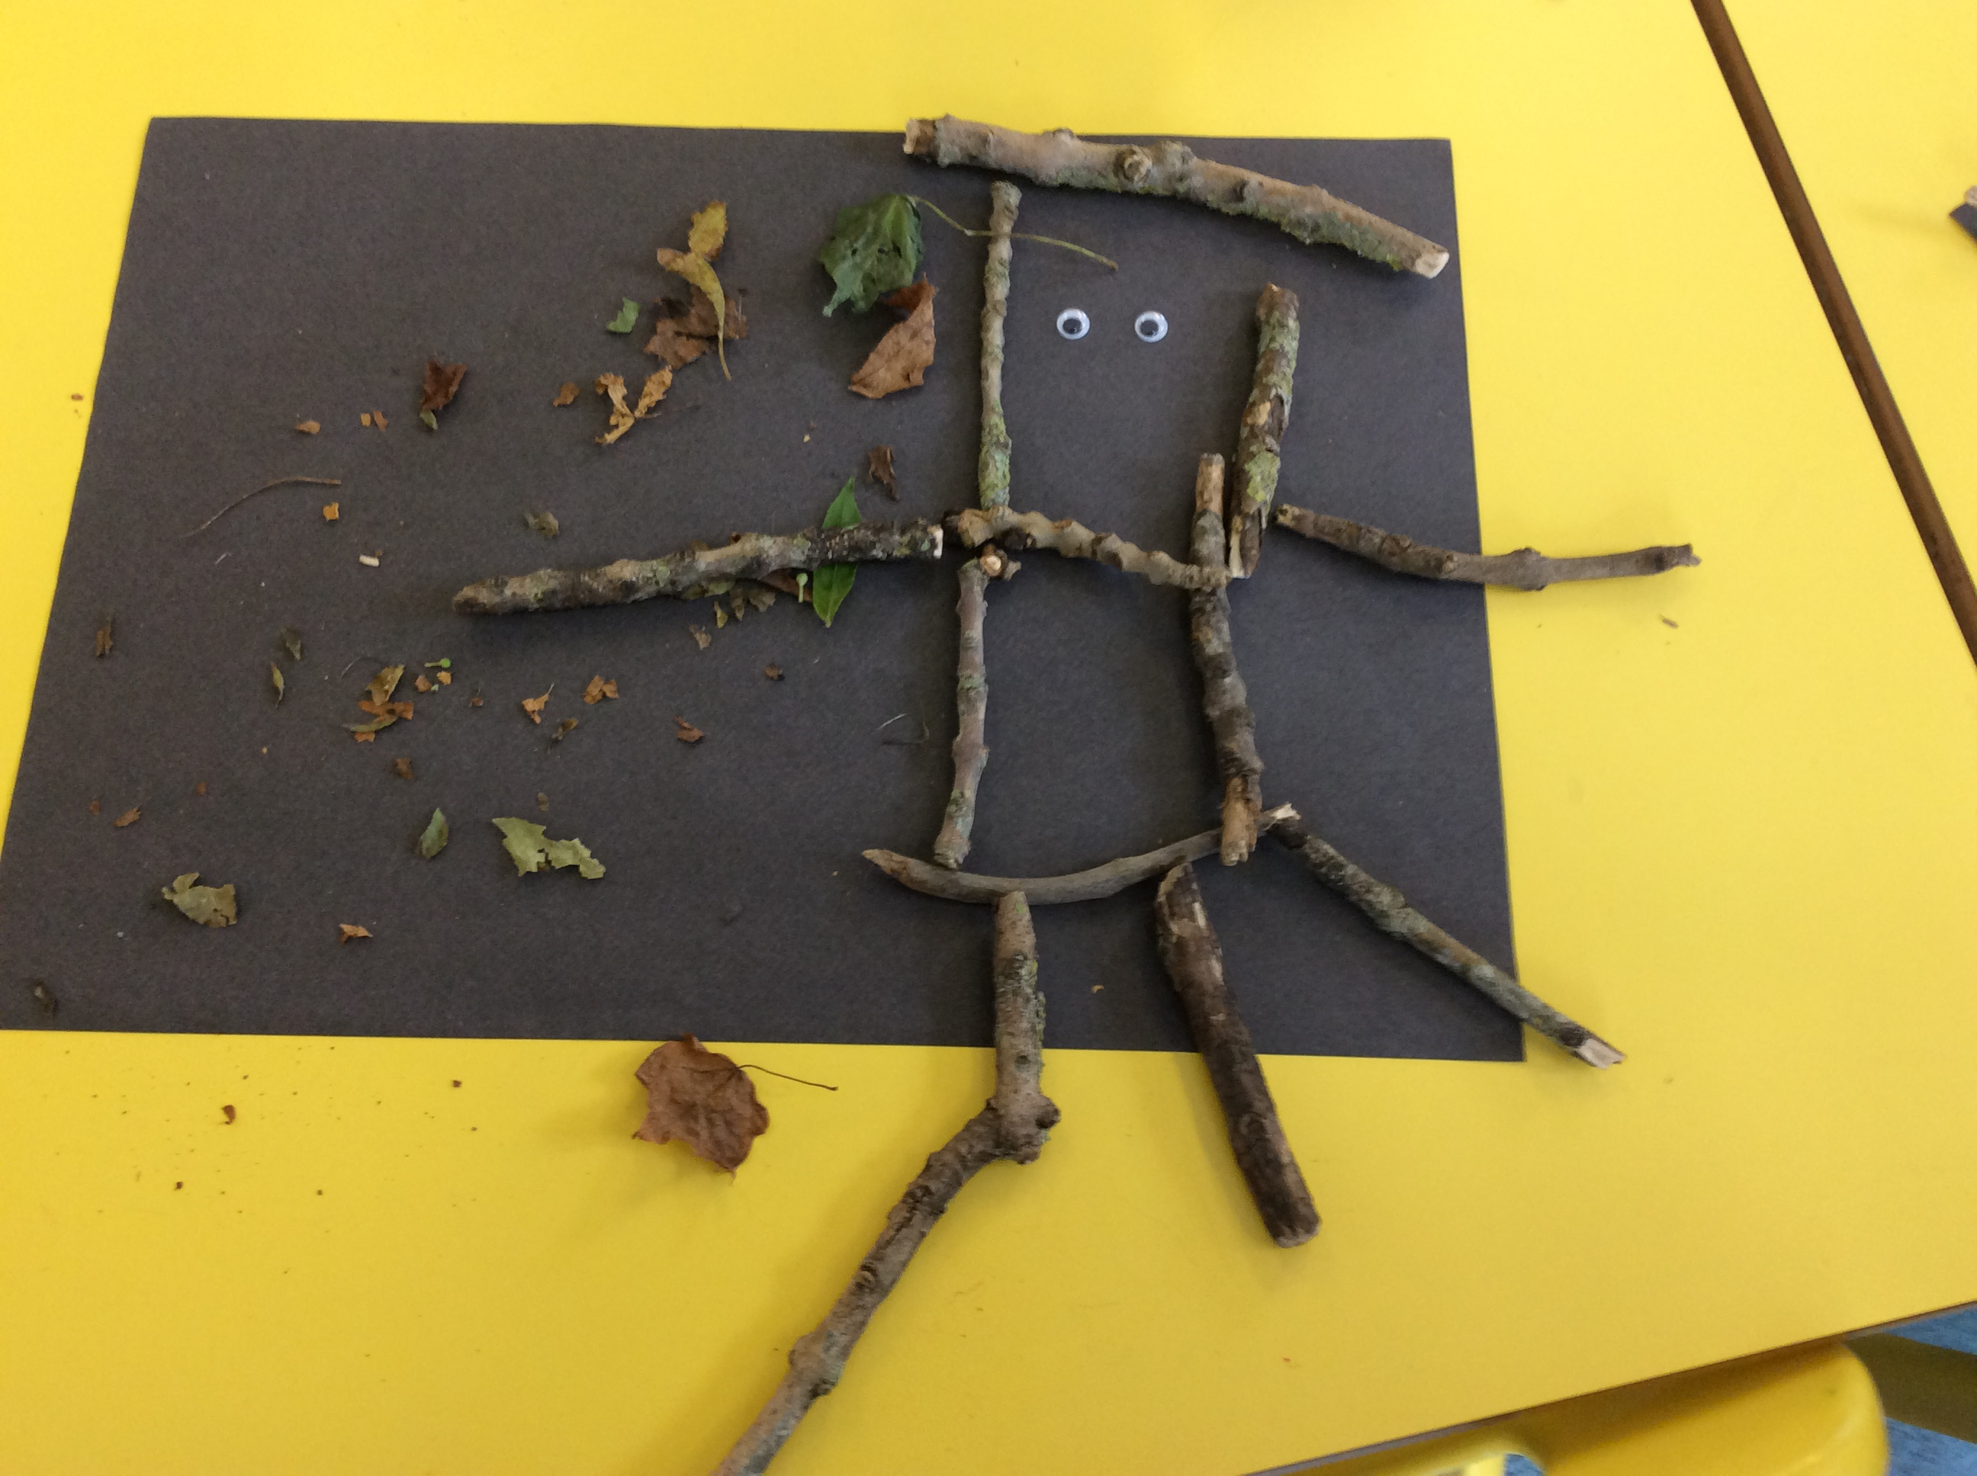

**Literacy**

This term we are continuing to develop our knowledge of phonics. In Primary 1 we will be continuing to learn the letters and sounds of the alphabet and in Primary 2 we are continuing to develop our knowledge of phonemes. We are enjoying learning about rhyme whilst reading Julia Donaldson books. The Primary 1’s are making a fantastic start to reading and will continue to broaden their knowledge of keywords. In Primary 2 we are focussing on reading more fluently and with expression. The class are enjoying becoming confident to speak in front of others through their presentations.

Numeracy

This term the children in Primary 1 will be consolidating number formations to 10 and will also begin to learn the concept of addition. The Primary 2’s will be consolidating numbers to 100 and will also begin learning the concept of multiplication. Christmas lends itself quite nicely to exploring shape and pattern in a fun and active way. We are always improving our mental agility by taking part in daily mental maths challenges.

Health & Wellbeing

This term we are learning how to care for others as well as keeping ourselves safe. In P.E we are developing throwing and catching skills in team games and we are fortunate to receive weekly basketball sessions from Active Schools.

Topic

This term we will be continuing our topic all about the ‘Gruffalo.’ We will be learning about woodland animals and how we can look after our local wildlife. We will be looking at how we can attract wildlife to the school garden to further our understanding of them. As the festive period approaches, the focus will move on to Christmas activities and celebrations!